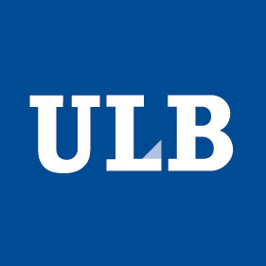

IAP 7/33

MECANISMS OF CONSCIOUS AND UNCONSCIOUS LEARNING
Kick-off Meeting

center for research in cognition & neurosciences @ ULB
February 15th, 2013

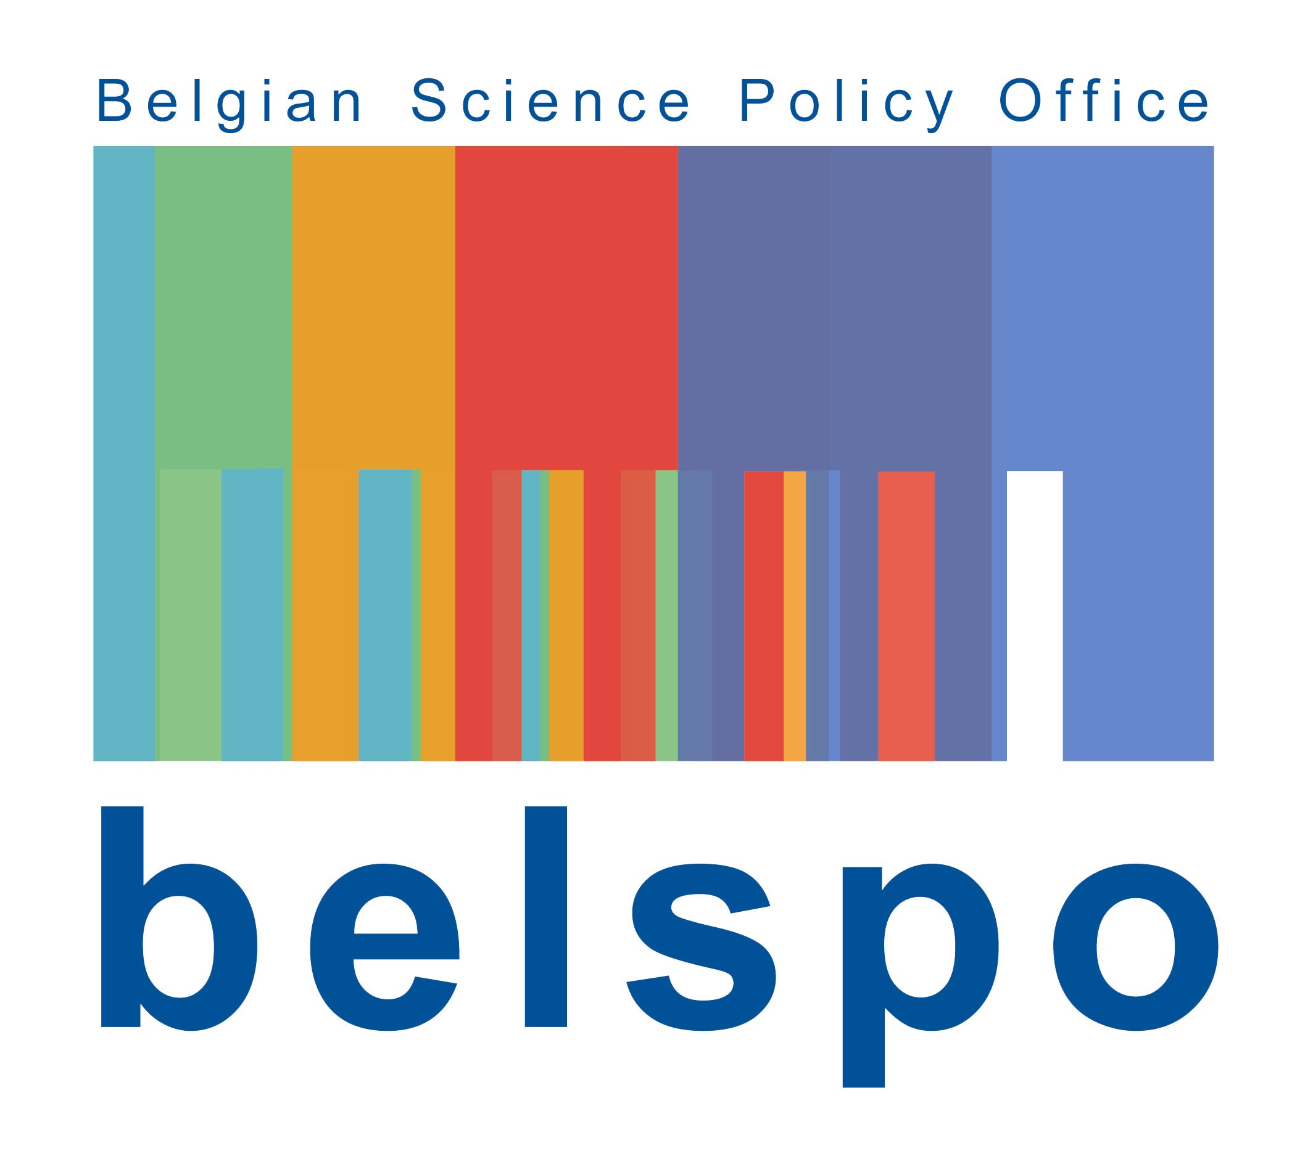

PROGRAM

9:00 Welcome coffee (Room DB10-233 – 10th level of the building)

9:30 Introduction – Axel Cleeremans (Room DC2-223 – Ground floor)

10:00 PI Presentations

10:00 Jan De Houwer
10:10 Marcel Brass
10:20 Tom Beckers
10:30 Bruno Rossion
10:40 Zoltan Dienes
10:50 Patrick Haggard

11:00 Coffee break (Room DB10-233)

11:20 PI Presentations (Room DC2-223)

11:20 Alain Content (LCLD)
11:30 Régine Kolinsky (UNESCOG)
11:40 Philippe Peigneux (UR2NF)
11:50 Axel Cleeremans (CO3)

12:00 Lunch (Room DB10-233)

13:00 Administrative meeting (Pls only) (Room DC10-219)

14:00 WP Presentations (Room DC2-233)

14:00 WP1 - Rossion/Peigneux
Mechanisms and dynamics of learning novel visual
patterns

14:20 WP2
Beckers/DeHouwer/Cleeremans/Peigneux/Kolinsky
Mechanisms of conditioning and causal learning

14:40 WP3 - De Houwer/Cleeremans/Brass/Beckers
Mechanisms of learning via instructions

15:00 WP4 - Dienes /Cleeremans/Beckers
Mechanisms of implicit learning

15:20 Coffee break (Room DB10-233)

15:50 WP Presentations (Room DC2-223)

15:50 WP5 - Brass/Cleeremans/ Haggard
Mechanisms of human decision making

16:10 WP6 - Haggard/Cleeremans/Brass
Mechanisms of instrumental learning

16:30 WP7
Cleeremans/Brass/Rossion/Haggard/Dienes
Mechanisms of awareness

16:50 WP8 - Kolinsky/Content/Rossion/De Houwer
Mechanisms of cultural learning

17:30 Drink ! (Room DB10-233)

DIRECTION

IAP KICK-OFF MEETING
Buiding D, Room DC2-223 (Ground floor)
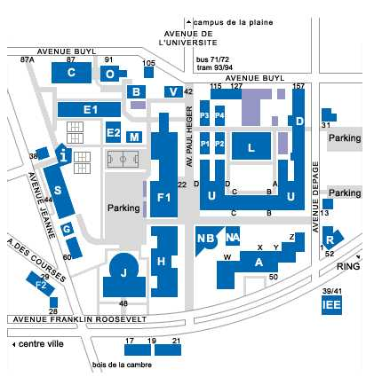

Solbosch campus

http://www.ulb.ac.be/campus/solbosch/plan.html

Contact
Angélique Bernacki,
Email abernack@ulb.ac.be
Phone : +32 2 650 26 31

