IAP 7/33

MECHANISMS OF CONSCIOUS AND UNCONSCIOUS LEARNING
Third Annual Meeting

Iers College, Leuven
conference room 1
December 11, 2014

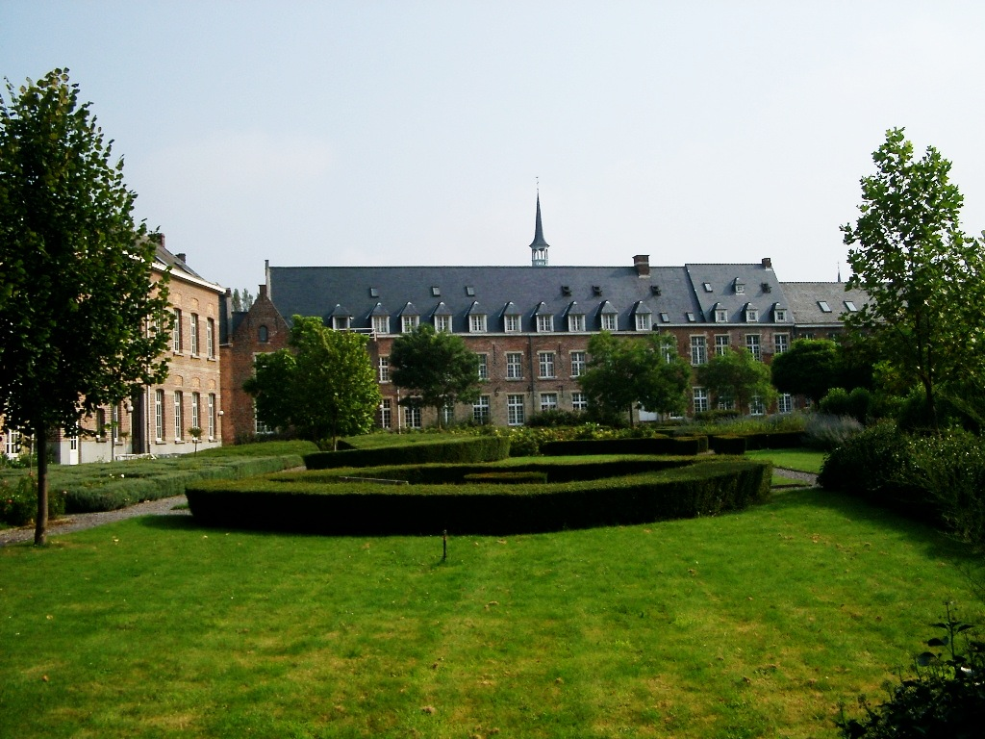

9.30 Introduction by Axel Cleeremans

9:40 Partner/WP presentations

What are we doing, who is doing it, what’s planned?

9:40 Brussels1 (Cleeremans/Peigneux)
Leading on WP7, partner in WP1-6

9:50 Brussels2 (Content/Kolinsky)
Leading on WP8, partner in WP2

10:00 Ghent1 (De Houwer)
Leading on WP3, partner in WP2, WP8

10:10 Ghent2 (Brass)
Leading on WP5, partner in WP3, WP6, WP7

10:20 Leuven (Beckers)
Leading on WP2, partner in WP3, WP4

10:30 Louvain (Rossion)
Leading on WP1, partner in WP7, WP8

10:40 London (Haggard)
Leading on WP6, partner in WP5, WP7

10:50 Sussex (Dienes)
Leading on WP4, partner in WP7

11:00 Coffee break

11:30 Research presentations

Presentations from junior researchers (PhD students and postdocs) involved in the IAP network

11:30 Senne Braem (Ghent)

11:55 Elisa Maes (Leuven)

12:20 Lunch + Administrative meeting (Pls only ; 13:00-13:50)

13:50 Research presentations

13:50 Irene Cogliati (Bruxelles)

14:15 Nura Sidarius (London)

14:40 Aliette Lochy-Sutovsky (Louvain)

15:05 Fabienne Chetail (Bruxelles)

15:30 Coffee break

16:00 Research presentations and keynote

16:00 Peter Lush (Sussex)

16:25 Keynote by Alfons Hamm (University of Greifswald)

Dynamics of defensive responses to threat (abstract below)

17:25 To the pub!

Dynamics of defensive responses to threat
Alfons Hamm, University of Greifswald

From the perspective of behavioral neuroscience fear and anxiety are emotional states that activate a defense system in the mammalian brain. This defense system regulates the encoding of threatening stimuli and organizes the response output to adjust to the threat. Animal data suggest that the amygdala is the core structure in this defense system. This subcortical defense system cannot only be activated by intrinsically innate aversive events (i.e., unconditioned threats), but also by conditioned previously innocuous stimuli that get access to the fear system after they have been associated with unconditioned threats. Importantly, defensive responses change systematically with increasing threat proximity, as outlined in the threat imminence model. According to this model non-threat specific hypervigilance is activated when the organism is in a context where a threat has been encountered previously (in clinical models this defensive behavior has been described as anxious apprehension or worry). When threat is detected defensive behavior switches to attentive freezing characterized by fear bradycardia and startle potentiation. During circa strike active defensive behavior (fight or flight) is engaged modulated by midbrain structures. Human data will be presented demonstrating the dynamic nature of defensive behavior comprising interacting adjustments both on the cognitive level of information processing but also on the level of automatic behavioral adaptations. Moreover, these behavioral adjustments correspond with differential neural network activation that also changes depending upon the proximity of the threat and the behavioral options that are available. Some clinical data will be presented to demonstrate how these neuroscience based models and empirical findings might be translated to the clinic and thus might provide better guidance for conceptualizing psychopathology of anxiety disorders beyond the level of pure symptom reports.

DIRECTIONS

Directions from railway station in Leuven to the Leuven Institute:

By Bus
The bus station is to the right of the Railway Station when exiting the railway station.
Bus number 2 (direction Naamsepoort/Heverlee) leaves from the railway station every 15 minutes (in rush hour between 07.00-9.00 and 16.00-19.00, every 8 minutes).
Get off at Sint Michielskerk (St Michael’s Church), which is on your left and on your right is the GB Express supermarket.
Walk down Sint Antoniusberg hill and arrive on Pater Damiaanplein.
On the left corner of the square is the Leuven Institute for Ireland in Europe.

Walking (20 mins)
Take Bondgenotenlaan (the big shopping street), which is the long straight street right ahead of you as you come out of the station.
Continue on this road and you will see St Peter’s Cathedral and the town hall as you approach the end of the street.
As you enter the Grote Markt- you will see the Town Hall in front of you. Keep St Peter’s Cathedral on your right and the town hall on your left.
Exit the square at the far left corner, with Krokodil toy store opposite you. You will then pass the McDonalds on your left. You are now in the Oude Markt (the Old Square).
In the Oude Markt, walk to the very end and turn right onto a short downhill slope and then turn left onto Parijsstraat.
Follow Parijsstraat- you’ll see ‘‘Cafe t’Vervolg’’ at the end of the street. Walk towards this until you come to Pater Damiaanplein (small square on your right).

Go to the bottom of the square and take the small street on your left-hand side.
The Leuven Institute is the first building on the left. It is a redbrick building with a glass door. You will need to ring the bell on the right-hand side to gain entry.

For more information, see http://www.leuveninstitute.eu

Contact
Tom Beckers
tom.beckers@ppw.kuleuven.be
+32 16 32 61 34

